Event Parners: | The Regina Anti-Poverty Network |  |  | 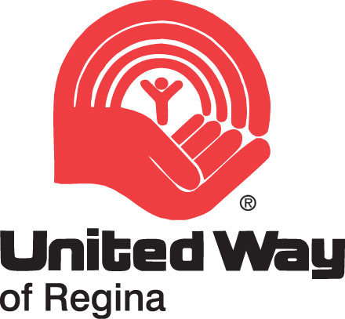 | 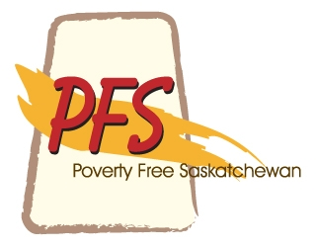 | 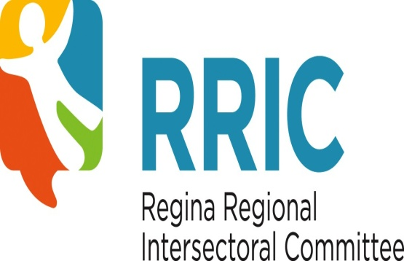
Poverty Free Saskatchewan, along with its partners
the Regina Anti-Poverty Network,
the United Way Regina, and
the Regina Regional Intersectoral Committee,
is pleased to host a community consultation to discuss

Strategies to Eliminate Poverty in Saskatchewan

Join local and provincial resource people in a discussion on eradicating poverty in our province.

9am – 12pm, Monday, November 21
United Way Regina Community Room
1440 Scarth Street Regina

Please RSVP to Jody at hanson5l@uregina.ca or at 306-653-0065
Honoraria will be provided to a limited number of first voices participants.

“Saskatchewan people have the ability to end poverty in our province.”

